**Post: Teacher of** **Art and SEN at Colaiste Iascaigh**

**Job Ref: PP3913**

**Interview Date: Thursday, 15th May 2025.**

**Candidate Protocol for connecting remotely from own location**

Dear Candidate,

Thank you for your response, confirming your intention to connect remotely from your own location.

Please be advised that it is the responsibility of candidates to ensure that they have access to the required software, device and connectivity to facilitate their attendance at interview (*please refer to initial notification letter in respect of ICT requirements*). MSL ETB will not take responsibility for any inability on the candidate’s part to connect remotely to the interview nor will there be an onus on MSL ETB to re-schedule an interview arising from the candidate’s inability to connect remotely outside of the allocated interview date/time.

**Please note the following conditions in respect of your preferred option**:

* You are required to bring your mobile phone with you to interview (switched to silent) in the event of technical difficulties so that HR personnel can contact you. We require your mobile number for this purpose only. Please ensure that you provide us with a contact number, if you have not already done so on your application form.

Every effort will be made to resolve technical issues which may arise within the time allocated for contingencies. Where the issue extends beyond the allocated time, the interview may be re-scheduled within the timeframe already scheduled for this particular post.

* You are required to provide MSL ETB with a personal email address, if you have not done so already. You will be issued with a link via email prior to your interview date which will enable you to access your interview through Teams.
* In upholding the privacy rights of all individuals who are present at the interview, it will not be recorded through audio, video or other means. Each person’s participation in the interview is conditional upon such prohibition of recording, irrespective of the purpose of any intended use of such a recording, personal or otherwise.
* Candidate must confirm that no other person will be in the room during the interview. You may be requested to show the room in which you are located to the Selection Board at any stage during the interview.
* You are requested to confirm that you will download and access the relevant software on the remote device and location that you will be using for the interview in advance of the scheduled interview date. The device and meeting software should be tested, ideally a number of working days in advance so that any potential issues can be resolved in time.

***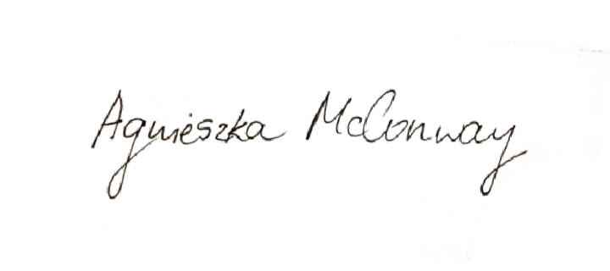*I CONFIRM THAT I HAVE READ, UNDERSTAND AND ACCEPT THE CONTENTS OF THE ABOVE PROTOCOL FOR CONNECTING REMOTELY FROM OWN LOCATION.**

**Signature of Applicant:**  **Date:** 11.05.2025

PLEASE RETURN THIS PROTOCOL SIGNED AND DATED TO [hrsligo@msletb.ie](mailto:hrsligo@msletb.ie)